2nd proposed Modification BITX20

In the BITX17 I have build, the audio was horrible as soon as a louder signal was received (the IF frequency I use is about 4.9 MHz but the problem can also arise with an IF of 10 MHz).
I found out that a lot of HF caused this problem, entering the audio traps via the mixer.
By adding a 0,22 µH coil (resistor look alike type) between the mixer and the audio traps, the problem was solved. This is not a clear calculated coil, it tried this one because it was on my table (it result in a high impedance for the HF signal and not high for the audio frequencies).
I added also the 10 nF capacitor to have at least the mixer at a certain ‘reference’ level. This value is not too high to short circuit the audio frequencies, it works fine.

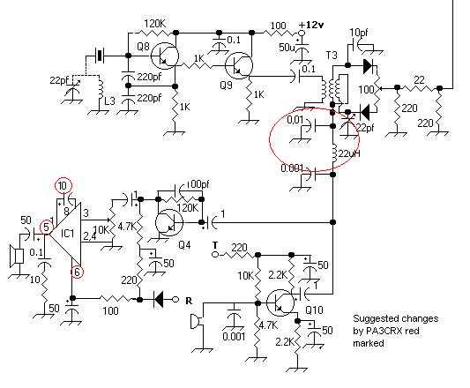
Please be aware to have the audio output and the voltage of the LM386 connected on the correct points! It is mentioned several times in the newsgroup but the schematic is not changed. In the schematic above it is corrected.

To have more gain of the LM386, the value of the capacitor between pins 1 and 8 must be increased to 10 µF (I used a tantalium one).

(The last two points can be found in the data sheet of the LM386).

Good luck,
Chris,
PA3CRX

