Proposed Modification BITX20

To improve the performance of the mixer with the four diodes, a DC path can be added.
I did it by adding a 100 μH coil (resistor look alike type) on the connection point of the capacitors (that are connected to Q2 and Q12) and the two diodes.
The output increased and the local oscillator level that passed the mixer was reduced.
Any type of RFC should be able to do this job, easy to check what the result of this modification is.

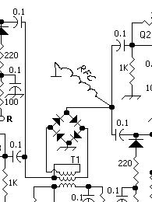

The other mixer has its DC path via the resistor of 220 Ohm, however, adding a 22μH coil (resistor look alike) also improved the output (a bit) and reduced (seen with an oscilloscope) the AF component that passed the mixer.

An other point to consider (it did not do it but it could help) is selecting the diodes by measuring the resistance and match them as close as possible.

Good luck,
Chris,
PA3CRX

