Amplifier stages BITX17 (may be useful for BITX20).

A major difference with the original schematic is that I do not use a bifilar transformer between the 2N2219 and the IRF but a trifilar transformer. This gives much lower impedance to the gate of the IRF510, better match, resulting in much more output. Also at the output of the IRF510 I used a trifilar transformer
An other thing to optimize is a capacitor between the drain of the IRF510 and ground.
Measuring the output, and keeping it constant with different values of added capacitors (manipulating the LF level of the LF- generator), I wrote down the input power (current and voltage). Then I calculated the efficiency result of the added capacitors and found out that it makes quit a difference. Without capacitor the efficiency is 30%, with 270pF it is 55%! Also the total power is higher. Because the capacitor is depending on the construction (and it is the result of the 17 meter BITX), I would like to advice you all to check what the optimize capacitor is on your amplifier (and share the results with us).
I kept the idle current low to prevent oscillations; it is in the order of 100 – 200 mA, the output power is then about 6 watts. With a higher idle current (for example 700 mA) the total output power increased to 7 watts (in dB’s it is not much more so I reduced it to have it more stable.

Because my amplifier was for the 17 meter band and I had to recalculate the low pass filter (and I did not want to use the toroid cores), I used the program ‘Elsie’.
This program calculates several filters, shows a lot of curves but also optimize and let see what happens if components are not really the calculated value.
Also inductance of coils (without core) can be calculated.
The link to this is posted by me in ‘Links’.

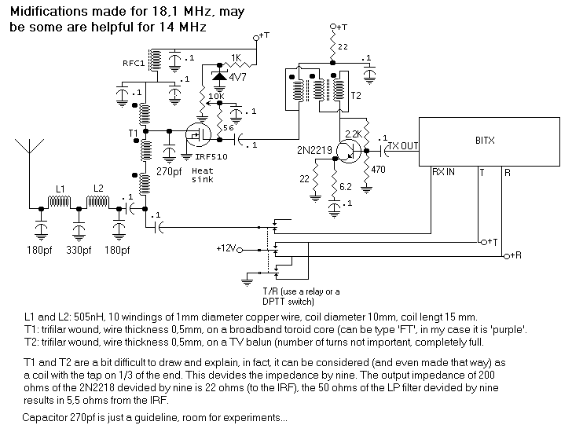

Chris,
PA3CRX

