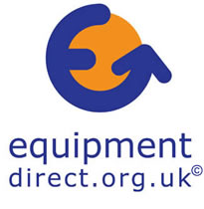


New choices for older and Disabled People

Older and Disabled People’s ability to live independently will be significantly improved as a result of an agreement between Equipmentdirect.org.uk and the Disabled Living Foundation (DLF), a national information charity.

A national online service will be developed to enable Equipmentdirect.org.uk to provide older and Disabled People the opportunity to carry out their own self-assessment and access information on over 14,000 pieces of equipment to aid independent living.

The DLF has granted Equipmentdirect.org.uk a licence to use DLF Data, its unique database of equipment with an interface provided by SARAbility (Self Assessment, Rapid Access), software developed in conjunction with the Department of Health’s Integrating Community Equipment Services team over the past two years.

‘SARAbility will enable older and Disabled People to have direct access from their homes to the widest range of information and advice on assistive technology, promoting choice and independence.’ explains Nicole Penn-Symons, chief executive of the DLF. ‘Equipmentdirect.org.uk and the DLF realised that there was a synergy between the two organisations’ aims and objectives and so, following a Trustees’ meeting, we decided to work together.’

Equipmentdirect.org.uk is funded by the HM Treasury scheme, ‘Invest to Save’, and will be working with the DLF to have a pilot running from autumn 2005 and be fully operational by the summer of 2006. This online resource will then be used to prove a concept and attract future funding.

It is an example of the Government’s commitment to the voluntary sector as it develops new ways of supporting older and Disabled People.

‘This collaboration is the best use of public money,’ says Hazel Peasley, Chairperson of the Hampshire Coalition of Disabled People and Equipmentdirect.org.uk. ‘In SARAbility the DLF has developed a very valuable resource and it will avoid unnecessary duplication of work for Equipmentdirect.org.uk whilst fulfilling the DLF’s aim to develop their software with other parties. Now the project can move forward more quickly.’
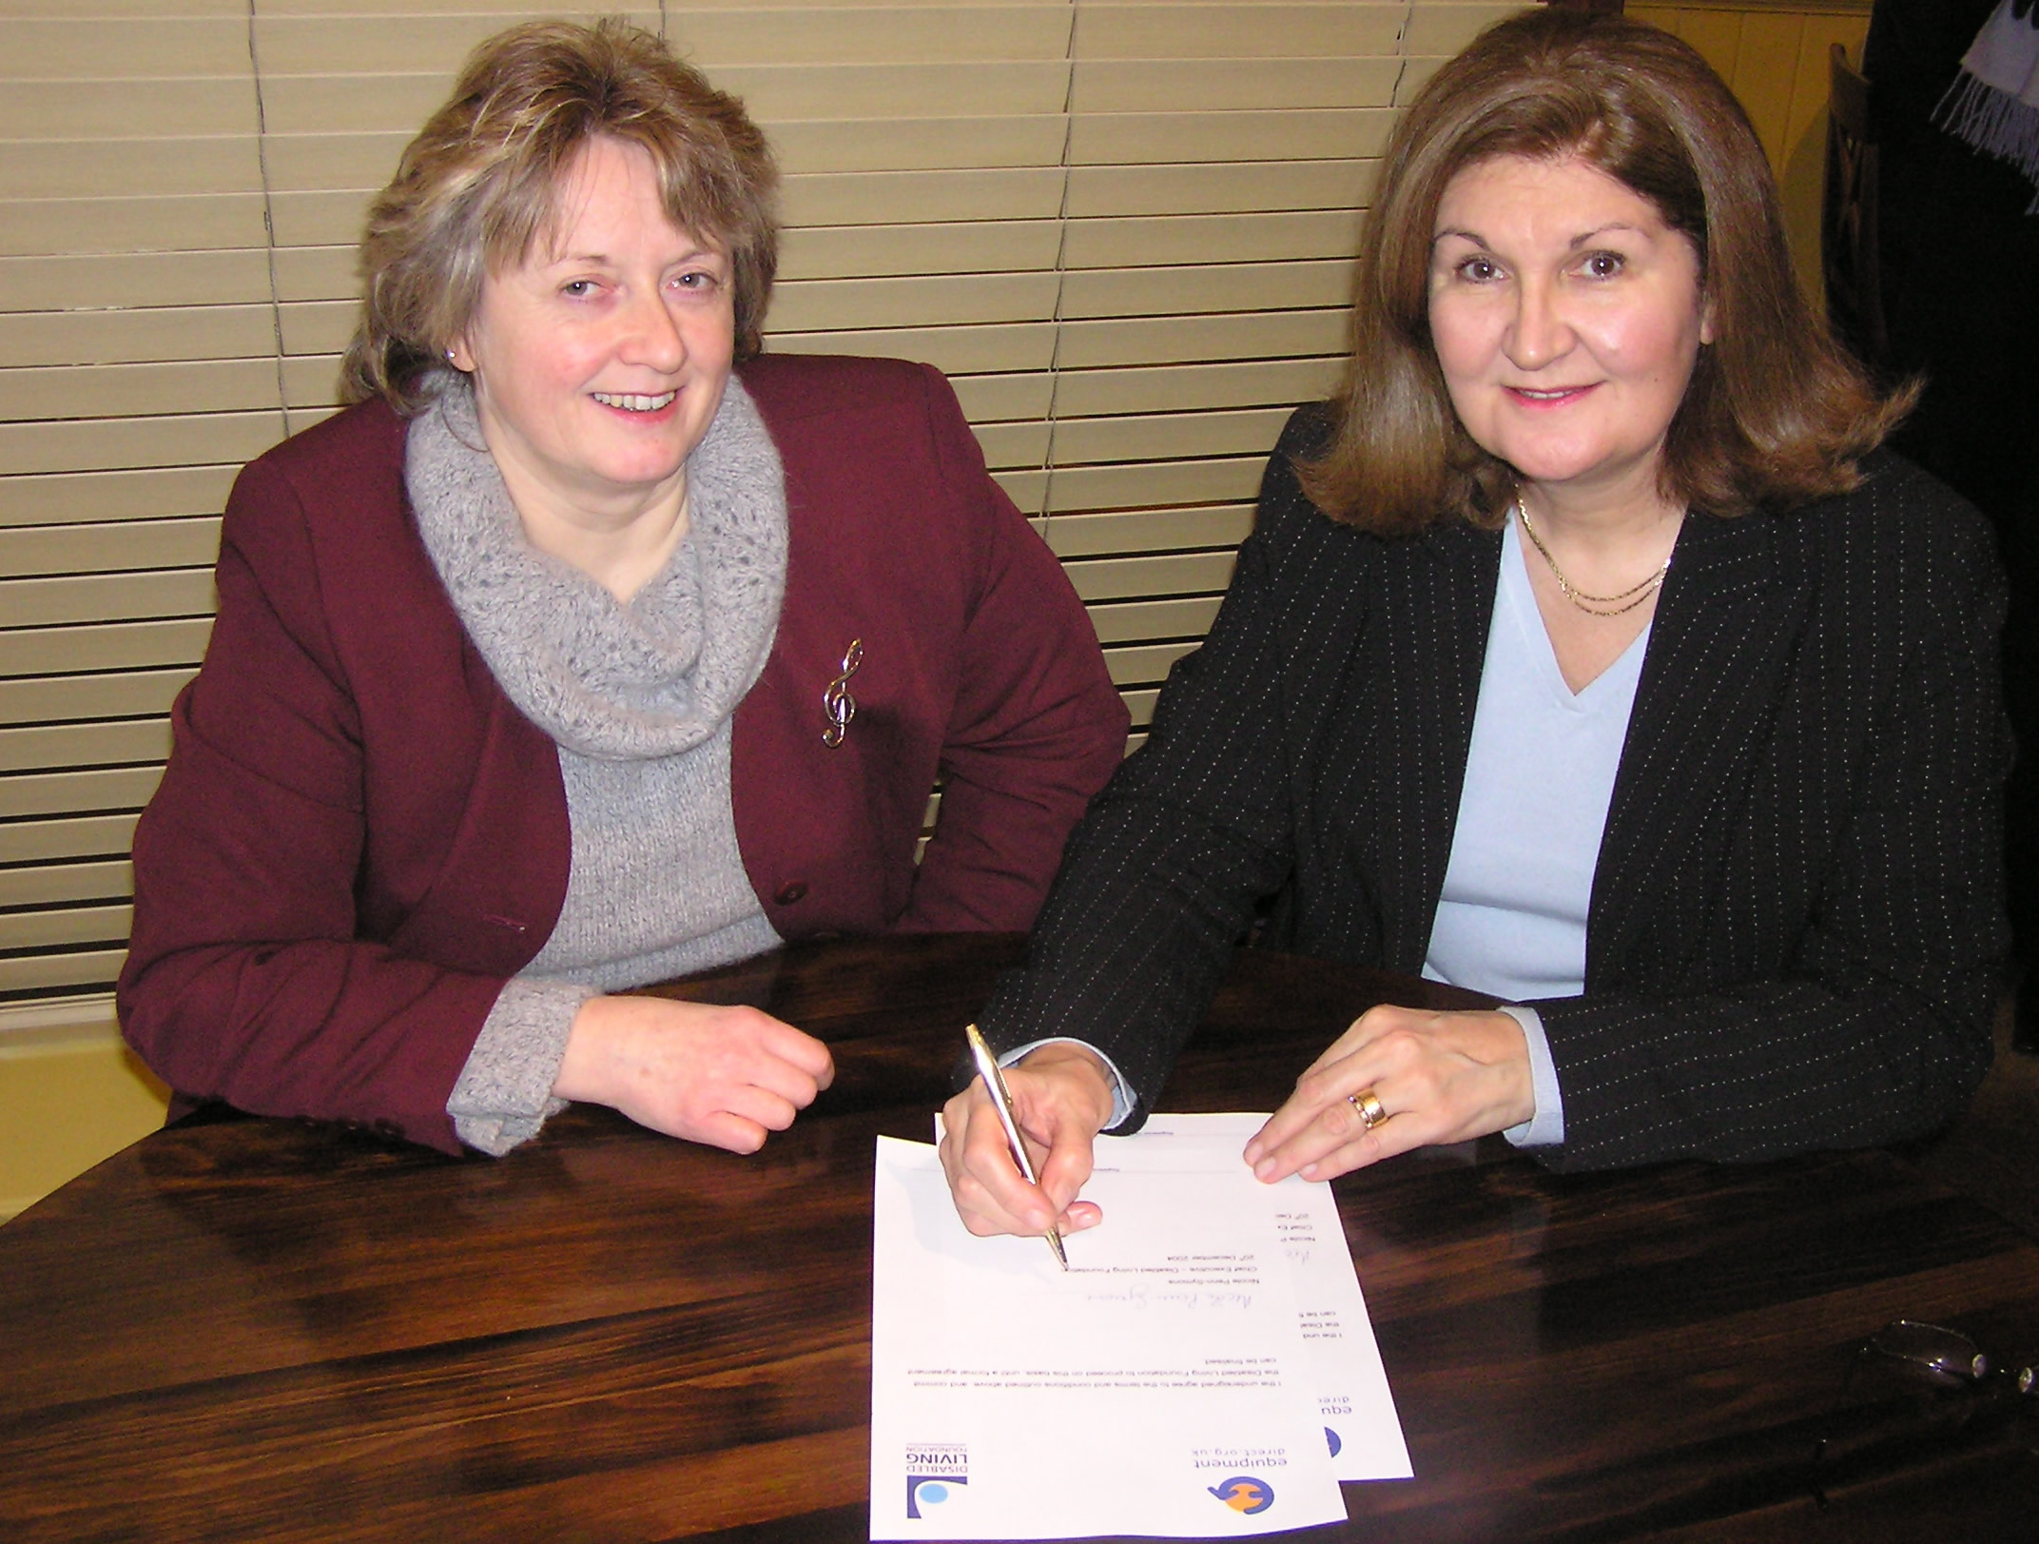
Hazel Peasley, Chairperson of Equipmentdirect.org.uk and

Nicole Penn-Symons, Chief Executive of the DLF sign the
working agreement.

