T | Digital Divide Policy in Chinese Taipei | Doc no:  Telwg30/  TELE/05

Agenda item :  1 | APEC Telecenter Workshop | Submitted by:  Chinese Taipei

Digital Divide Policy in Chinese Taipei

Contact: Yu-Chuan (Michael) Lin
Email: yuchuan@rdec.gov.tw

APEC Telecommunications and Information Working Group
30th Meeting | 19-24 September 2004 | Singapore

Please note:
This document is not an official APEC document until approved by the Telecommunications and Information Working Group. This version is a draft provided for discussion purposes only.

Digital Divide Policy and Telecenter Development

Yu-Chuan Lin (Michael)
Senior Analyst
yuchuan@rdec.gov.tw

Research, Development, and Evaluation Commission
Chinese Taipei
September 15, 2004

Abstract

The article gives a brief report on the government’s policy and practice related to bridging the digital divide in Chinese Taipei. Based on a recent survey, it gives some introduction information about the digital divide situation. The gap caused by geographical difference is obvious. The government’s policy on bridging the digital divide was firstly included in a NII Promotion Program since 1997. Under this Program, The Research, Development and Evaluation Commission (RDEC) finished the establishment of 141 telecenters in remote areas in 2001. In 2002, a Challenge 2008: National Development Plan adopted more concrete policy for bridging the digital divide. This Plan achieved better collaboration and integration among government agencies/departments for the efforts in bridging the digital divide, and the RDEC finished the establishment of 71 telecenters in 2003. Based on the experience from relevant projects, the article provides some important findings for telecenter development.

I. The situation of digital divide
Accompanied with good manufacture capacity and playing as an important role in the global ICT industry, Chinese Taipei has achieved good progress in the widespread usage of ICTs in last decade. As of January 2004, the number of Internet population reached to 12.64 million. Among the Internet population, 71.44% of them are broadband users. The relevant e-readiness figures are illustrated in the table below.
E-readiness in Chinese Taipei (January 2004)
Items | Penetration Rate
Internet Population | 61.01%
Broadband Users | 71.44%
Households Connection | 71.58%
Broadband Households | 71%
Mobile Phone | 106.45%
Cable TV | 84.6%
Source: 1. Taiwan Network Information Center
2. Ministry of Transportation and Communications

In accordance with the development and application of ICTs, the digital divide exists in every society in the world. Accordingly, Chinese Taipei is not an exception. Between urban and rural areas, rich and poor, there still exists the digital divide. Based on a survey by the Research, Development and Evaluation Commission (RDEC) in June 2003, the digital divide caused by geographical difference is obvious. The gap in computer ownership level and Internet access between urban and rural areas is illustrated below.
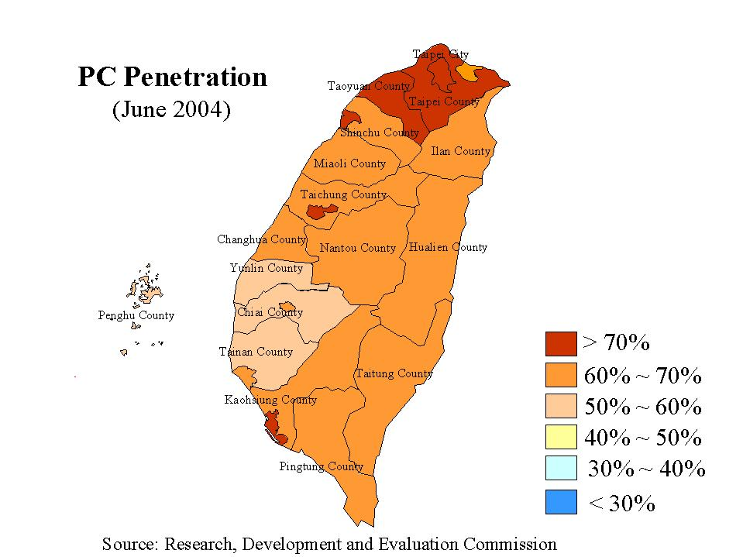
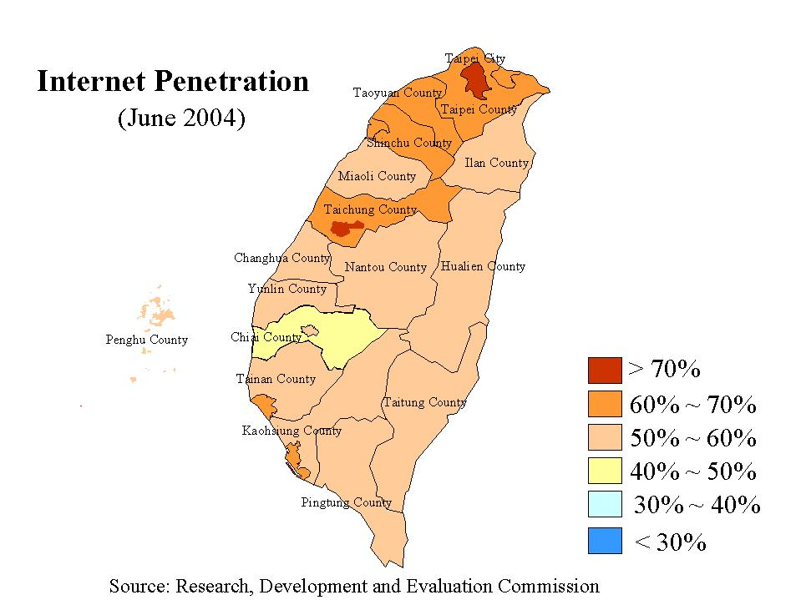

II. Government’s policy and plans on bridging the digital divide
To promote the widespread development of ICT applications, the Executive Yuan (the Cabinet) established the NII Task Force in 1994. Then in 1997, the NII Promotion Program (1997 ~ 2001) was established for NII related strategies, measures, and implementation schedules. In the Program, the measures for bridging the digital divide were included, such as speeding up the construction of fiber telecommunication backbone, building wide-spread public information centers/kiosks, establishing Internet-connected computer labs in every elementary and junior-high school, promoting telecommunication universal services, enhancing information education and training, developing digital content industry, strengthening services for disabled people on learning, working, and living. Under this Program, the RDEC launched a project to establish telecenters in remote areas since 1999. In three years, the RDEC finished to establish 141 telecenters. This was the first stage to develop rural area telecenters.
In 2002, the issue for bridging the digital divide was highlighted furthermore by the Executive Yuan in the Challenge 2008: National Development Plan. The following measures related to bridging the digital divide were adopted.
(1) Strengthening information education for elementary and middle schools in remote areas.
The government increased budget for training teachers in remote areas to become competent in incorporating information technology into all subjects.
(2) Promoting information education and training programs for indigene
The government continued to allocate budget to set up Internet classrooms and public information centers in indigenous communities, and to hold various kinds of training courses to equip indigene with the competence to use IT.
(3) Implementing information education and training programs for laborers, farmers, and senior citizens
Incorporating resources from vocational training institutes, universities, expert groups, and the private sector, the government kept providing laborers, farmers, and housewives with basic IT training. The average number of trainees was 12,000 persons per year.
Under the framework of National Development Plan, the RDEC was in charge of monitoring variety of projects executed by relevant ministries/agencies in the government. Every three months, the RDEC held a meeting to review each ministry/agency’s progress in relevant projects. Some coordination among ministries/agencies was also made by the RDEC. In addition, based on the experiences and lessons learned from the first stage of telecenter development, the RDEC continued to establish 71 telecenters in remote areas in 2003, which is the start of the second stage of government efforts in this regard. In 2004, there were 33 more telecenters established in rural areas.

III. Telecenter Establishment and relevant experiences
- Remote areas
a. Definition
According to the definition of remote area given by the government, the total number of remote villages is 702. Each village or borough owns a small territory normally with population under one thousand in rural areas.
b. Stage one
To bring the people of remote villages into Internet world, the RDEC launched a project to establish telecenters in remote areas in the mid of 1999. NT$35 million, about US$1 million, was appropriated for this project. The RDEC requested proposals from private sector through open bidding. A proposal specialized in integrating resources from religious groups won the contract, which used many churches as the sites for telecenters. By the end of 2001, the RDEC built 141 telecenters in remote areas. The distribution of these telecenters is illustrated as the table below.
<Table 2> Distribution of telecenters by RDEC
Counties | No. of telecenters in remote areas
Taipei County | 1
Ilan County | 6
Taoyuan County | 2
Hsinchu County | 21
Miaoli County | 6
Taichung County | 2
Nantou County | 3
Yunlin County | 1
Chiayi County | 4
Tainan County | 1
Kaohsiung County | 3
Pingtung County | 7
Hualien County | 39 (including 10 with Kiosk-model)
Taitung County | 37 (including 10 with Kiosk-model)
Penghu County | 5
Kinmen County | 1
Lienchiang County | 2
Total | 141

In order to evaluate a proper implementation model for telecenters in remote areas, there were two different types of computer configurations in this project. One was PC-model for 121 points. The other was kiosk-model for 20 points. For the PC-model, the telecenters were each equipped with two PCs, one printer and a web-camera. The computer was connected to Internet using dial-up. The bandwidth and speed of the communication were lower comparing with today’s ADSL. The government provided computer and network facilities, maintenance, Internet usage fee, and training. Meanwhile, the owners of the sites provided the space, electricity, work force, and operation management for telecenters. Among these 121 sites, 78 of them were located in churches. The churches were expected to integrate these telecenters with their activities in local communities to help promoting information and Internet usage in remote areas. However, the result was not as ideal as the planning in the beginning.
The following are some problems found for PC-model:
- PCs were very easy out of order due to improper operations. The maintenance cost was very high in remote areas. Government is difficult to keep providing effective maintenance service in the long run.
- Lack of qualified work force for managing PCs and the promotion of Internet. The project encountered difficulties in training old Fathers and Sisters in churches.
- Lack of collaboration with local communities. Meanwhile, local communities lacked necessary resources to support telecenter development.
Due to the problems stated above, unfortunately, only around 30 telecenters survived by the end of 2002. From 2003, the RDEC did not take care of these telecenters anymore. It transferred them to local governments, including county governments and townships.
Regarding the kiosk-model telecenters, each was equipped with a wall-mounted Internet computer, which was similar to a public phone (illustrated in the pictures below). To use it, users need to get an IC card from the kiosk manager. The kiosks were open for public’s free use, during mid-1999 to the end of 2001. Government also needed to cooperate with local communities for taking care of the facilities. The local kiosk managers provided space, electricity, and work force. The installation locations for 20 kiosks included: community service centers, libraries, schools, civil organizations, tourist centers, district halls, and national parks.
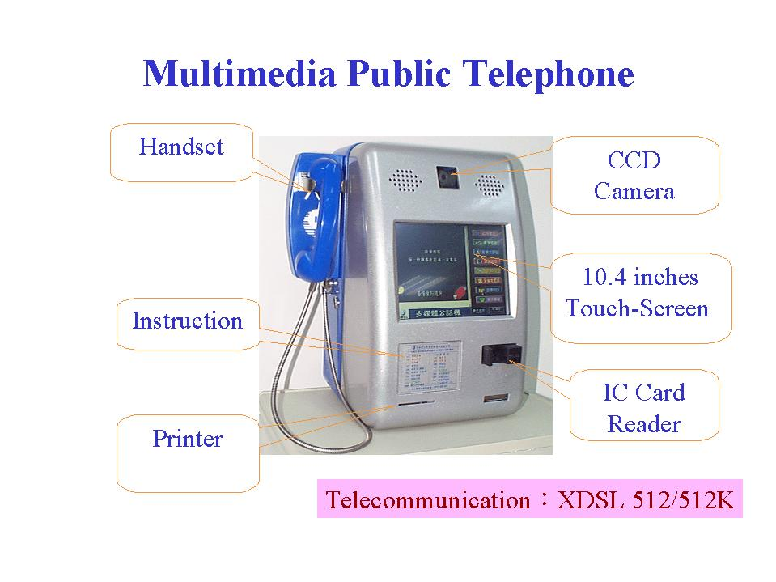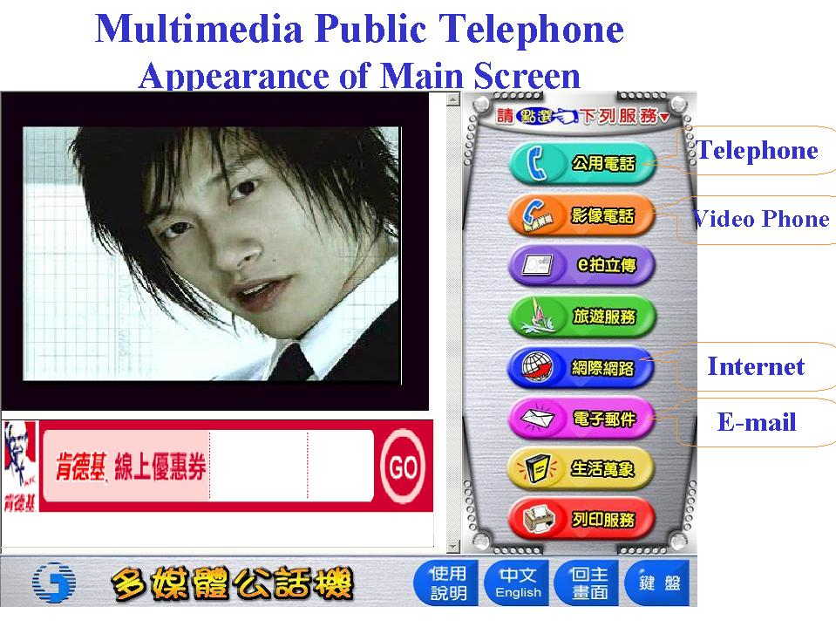

Comparing with PC-model, kiosk-model was easy for maintenance. The maintenance cost was lower. They could be monitored by remote control. That made things simple when their systems needed updated. The information about the usage condition of these kiosks was also easy to be collected centrally. Such kind of model is ideal for delivering information and services for public use. These 20 kiosks are currently under commercial operation by Chung-hwa Telecom Company.
Apart from government side, private sectors have also contributed to bridge the digital divide in remote areas. Since 2001, Microsoft Taiwan cooperated with ACER, SYNNEX and civil society established 3 e-Learning Amusement Parks in three different indigenous areas, including Tung-pu in Nantou County, Jane-shih in Hsinchu County, and Orchid Island. In each e-Learning Amusement Parks, there are 12 ~ 20 PCs and related facilities. The corporations donated computers and software. Meanwhile, local communities were responsible for operation, maintenance, management and promotion activities. Moreover, volunteer workers from universities were teamed up for supporting these telecenters.

c. Stage two
Based on the experiences and lessons learned from the first stage, the RDEC continued to establish 70 telecenters in remote areas in 2003. The strategy during this stage was different from that in the stage one. As previously mentioned, the RDEC adopted a centralized telecenter implementation strategy in stage one. However, a distributed implementation strategy was used in the stage two. Instead of contracting out the project, the RDEC requested for projects from local governments, and urged them focusing much more on how to cooperate with local communities, how to maintain the telecenters and how to promote Internet and information usage. Accordingly, the RDEC formed a committee to review the projects submitted by local governments. Then, eleven projects were passed and funded by the RDEC. In 2004, civil society and NGOs were included as the targets when the RDEC requested for telecenter projects, then 12 projects were approved and funded. The number of telecenters established in 2004 is 33, including those by local governments and NGOs.
The top three list of places where telecenters built in 2003 were village/borough offices, libraries, and community centers, taking the percentages of 34%, 26% and 18%, respectively. On the other hand, community center takes the majority of telecenters built in 2004. Thanks to the advance of telecommunication technologies, all telecenters in this stage used ADSL for Internet connection, which provided broadband service. Due to the better involvement from local communities, the performance of these telecenters is much better than which in stage one. To trace and evaluate the performance of these 70 telecenters, the RDEC conducted a survey in the August of 2004. The charts below illustrate the relevant findings.
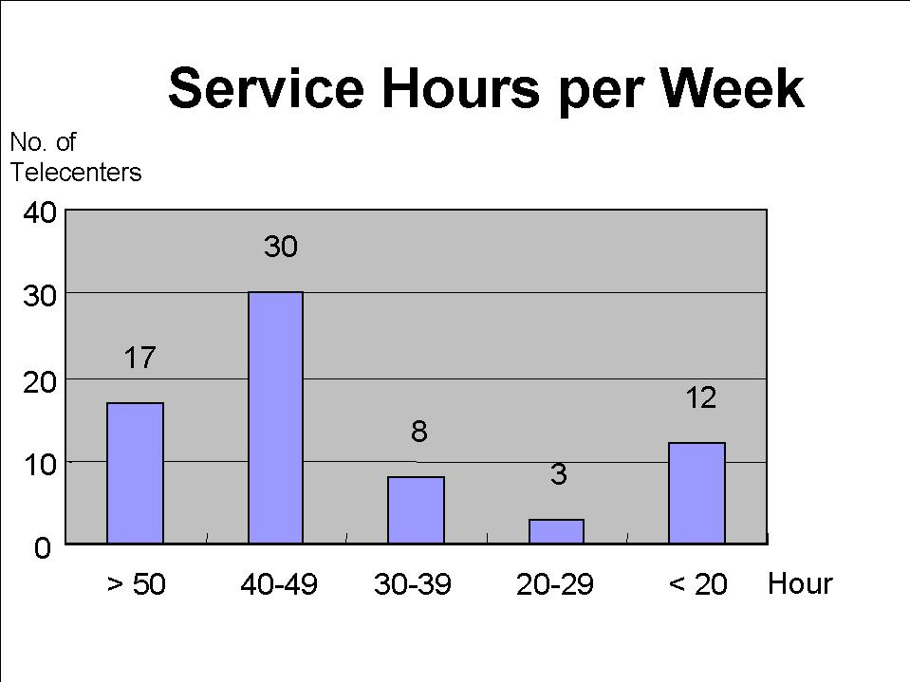
There were 30 telecenters located in the biggest group with 40-49 service hours per week. We set 4 service hours per day as a minimum requirement for a telecenter operation. Therefore, the number of telecenters that reached up minimum requirement is 55, which is 78% of 70.
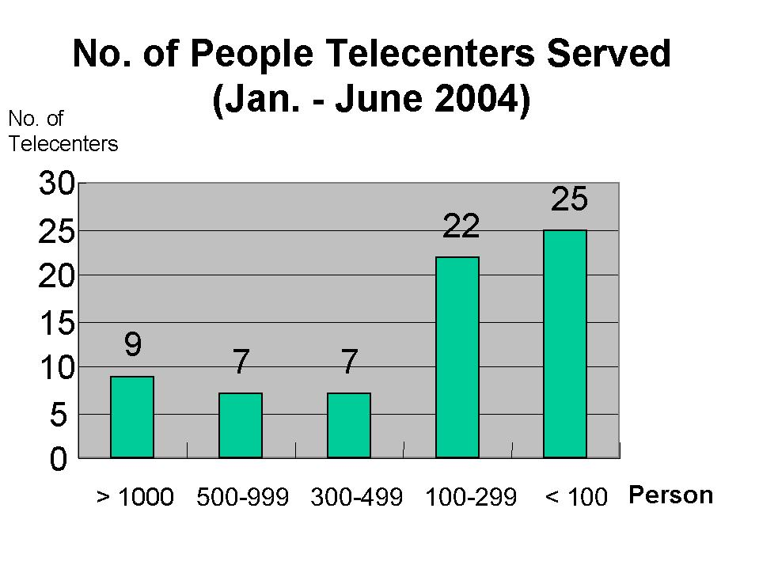
The chart above reveals the real usage of 70 telecenters during the period of six months. If a telecenter had five users each day, the total user number for six months is 900. Then it is 720 for four, 540 for three, 360 for two, and 180 for one. Therefore, we can see there are at least 45 telecenters each of which served less than two persons per day. Only around nine telecenters each served more than five users per day.
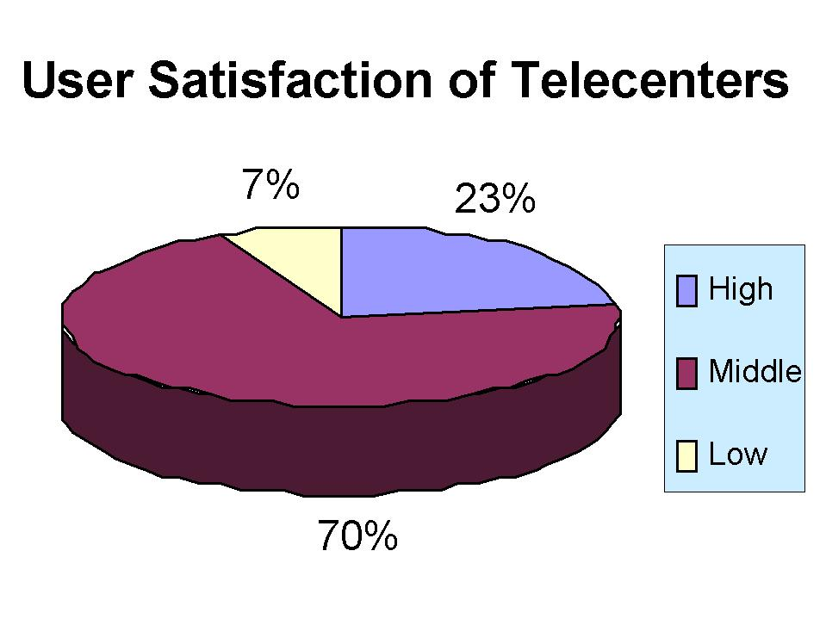
To evaluate user satisfaction, the degree that users felt how much they were benefited from telecenters was considered. Generally speaking, those telecenters managed by local communities owned higher user satisfaction. Below are two pictures taken in telecenters.

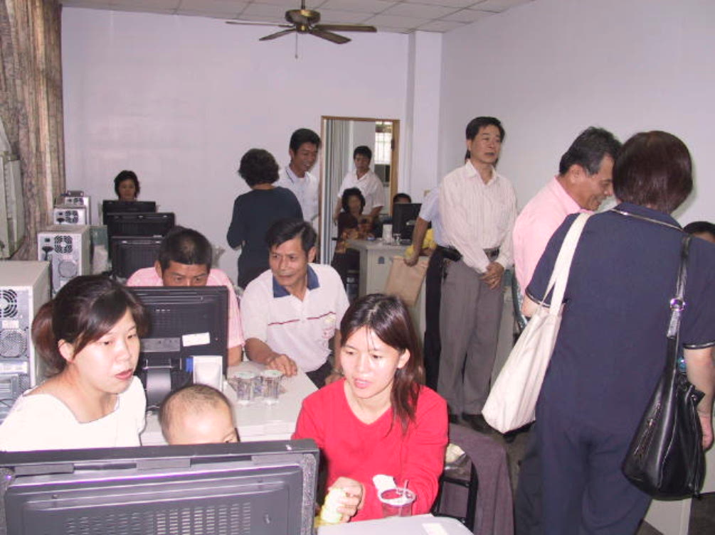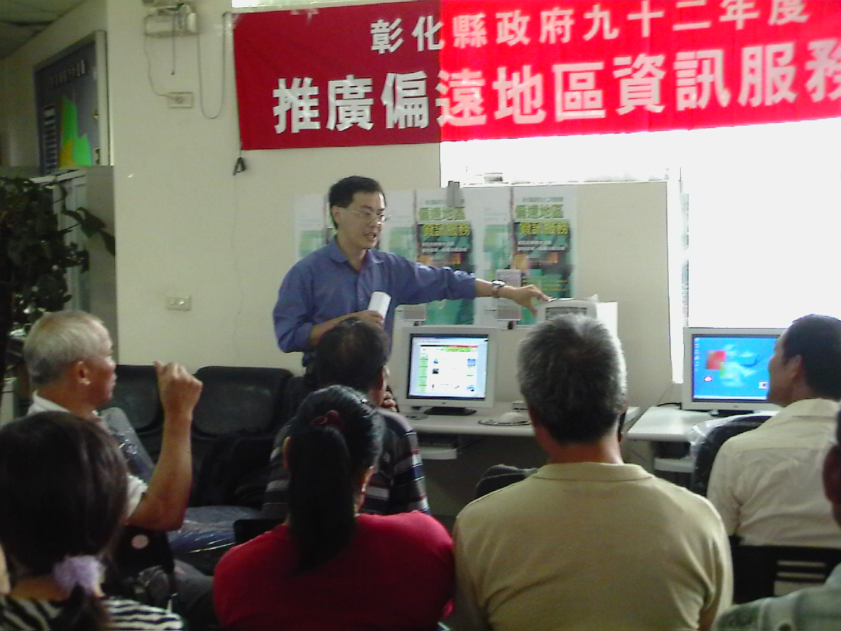

- Other areas (beyond remote areas)
To encourage citizens to use computers and the Internet, during 1996 ~ 1997, the RDEC cooperated with private sectors to provide free Internet services at 19 public places, including airports, train stations, culture centers, art museums, and libraries. Each Internet service site was equipped with a LAN connected by 10~50 PCs. Through the cooperation between governments and private sector, the RDEC was to create a win-win situation for both sides from the project. The government was responsible for providing the public space, electricity and telecommunication in the service site. On the other hand, the private sector provided computer and network facilities, maintenance, management and workforce. No only for building a better image, the private companies/institutes joined in this project also tried to increase business opportunity. By the end of 1997, the RDEC finished the project due to the government reached its goal on Internet population promotion. However, it seemed that the private companies/institutes didn’t get obvious benefit directly from the project.
For local governments, the efforts on bridging the digital divide varied wildly. However, in general, all public libraries have been connected onto Internet and played an important role for Internet services for general public. Among them, 20 public libraries have established e-Learning Amusement Park by the help of private sector to enhance the function of information training and Internet services. These 20 public libraries are all located in municipal areas, including Taipei City, Taichung City, and Kaohsiung City. In addition, all elementary schools and junior high schools all have Internet-ready computer labs, including remote areas. The government believes that strengthening information education to students is a very basic and critical issue for alleviating the digital divide.
Developing rich on-line content is an important issue in addition to promoting Internet access. In this regard, by the end of 2001, the RDEC helped 6,500 villages and boroughs to establish their own websites (http://village.gov.tw/), which not only helped to provide rich content and services to the society but also being helpful in bridging the digital divide. This website focused on developing local content and services. The RDEC offers incentives and cooperated with local governments to encourage the proactive involvement by the chiefs of villages and boroughs. Since each village/borough owns a small territory normally with population under five thousand in urban areas and one thousand in rural areas, through the project above, it was very helpful to bring up local communities’ involvement in the Internet promotion.

